CHAPTER 1
INTRODUCTION

1.1 Introduction to the Seminar Title
The term "Metaverse" was first coined by author Neal Stephenson in his 1992 science fiction novel Snow Crash in which he described a virtual reality-based successor to the internet where users interacted through digital avatars in a shared three-dimensional space [1]. Over three decades later the Metaverse has evolved from a fictional concept into a tangible technological frontier attracting billions of dollars in investment from technology giants startups and governments worldwide.
At its core the Metaverse can be defined as a collective virtual shared space created by the convergence of virtually enhanced physical reality and physically persistent virtual spaces. It is a persistent immersive digital environment where people can interact work learn socialize and transact in real time using technologies such as Virtual Reality (VR) Augmented Reality (AR) Mixed Reality (MR) blockchain artificial intelligence (AI) and advanced networking infrastructure [2].
The year 2021 marked a watershed moment for the Metaverse when Facebook rebranded itself as Meta Platforms Inc. signaling a corporate pivot towards building immersive virtual environments. This announcement catalyzed widespread interest from the technology industry with companies such as Microsoft NVIDIA Apple and countless others announcing their own Metaverse-related initiatives [3]. The global Metaverse market valued at approximately USD 65.5 billion in 2022 is projected to reach USD 1527.55 billion by 2029 growing at a compound annual growth rate (CAGR) of 47.6% [4].
This seminar explores the technological foundations architectural components current applications and future implications of the Metaverse with a particular focus on its transformative potential across various sectors of society and the economy.
1.2 Description of the Seminar Concept
The Metaverse is not a single product or platform but rather an interconnected ecosystem of technologies platforms and standards that together create persistent immersive digital experiences. Understanding the Metaverse requires examining its conceptual layers each of which contributes to the overall digital experience.
The concept of the Metaverse rests on several foundational pillars. First persistence refers to the property that the Metaverse exists continuously and independently of whether individual users are logged in; events occur economies function and the world evolves in real time [5]. Second synchronicity means that experiences occur simultaneously for all participants enabling shared real-time interactions across geographic boundaries. Third interoperability — perhaps the most technically challenging aspect — refers to the ability of users to carry their digital identities assets and experiences across different platforms and virtual worlds [6].
The technological architecture of the Metaverse can be understood through the seven-layer framework proposed by venture capitalist Jon Radoff which includes: the Infrastructure Layer (telecommunications networks cloud computing semiconductors) the Human Interface Layer (VR/AR headsets haptic devices brain-computer interfaces) the Decentralization Layer (blockchain smart contracts decentralized autonomous organizations) the Spatial Computing Layer (3D engines geospatial mapping digital twins) the Creator Economy Layer (design tools asset marketplaces workflow platforms) the Discovery Layer (app stores search engines social media integration) and the Experience Layer (games social networks entertainment education commerce) [7].
Key enabling technologies for the Metaverse include Extended Reality (XR) encompassing Virtual Reality Augmented Reality and Mixed Reality. VR creates fully immersive digital environments that replace physical reality AR overlays digital information on the physical world and MR blends digital and physical elements interactively [8]. Blockchain technology provides the foundational infrastructure for decentralized ownership identity management and economic transactions within the Metaverse enabling concepts such as non-fungible tokens (NFTs) and decentralized finance (DeFi) [9].
Artificial Intelligence plays multiple roles in the Metaverse from generating realistic non-player characters (NPCs) and environments to personalizing user experiences detecting fraudulent behaviour and enabling natural language interaction [10]. High-bandwidth low-latency networking — particularly 5G and the emerging 6G standards — is essential for supporting the massive data throughput required for real-time immersive experiences at scale [11].
1.3 Applications of the Concept
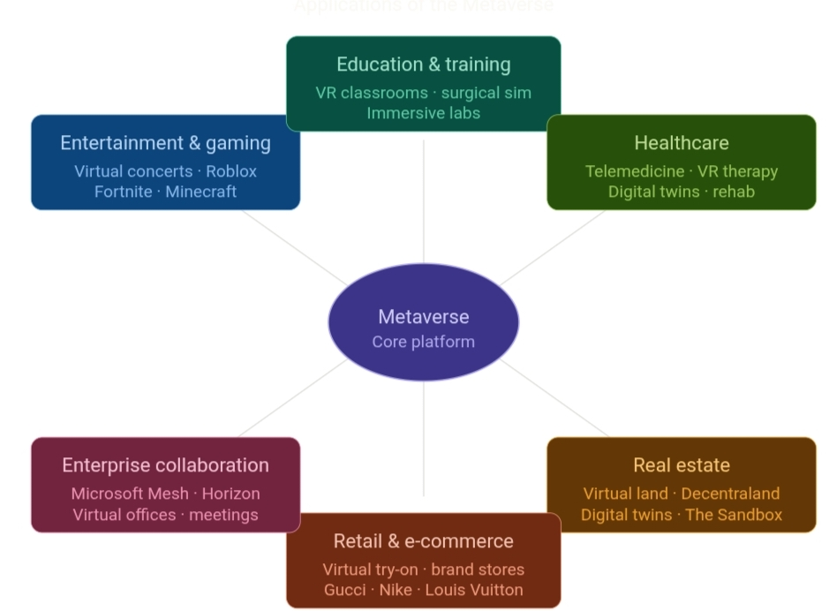
The Metaverse has significant implications across numerous sectors. Its applications span entertainment and gaming education and training healthcare real estate retail and e-commerce enterprise collaboration and social interaction among others.

Figure 1.1: Applications of the Metaverse
1.3.1 Entertainment and Gaming
Gaming has been the earliest and most mature application domain of Metaverse technologies. Platforms such as Roblox Fortnite and Minecraft already exhibit proto-Metaverse characteristics hosting virtual concerts social events and commerce within their ecosystems [12]. Epic Games' Fortnite for instance hosted virtual concerts by Travis Scott and Ariana Grande that attracted tens of millions of concurrent attendees demonstrating the entertainment potential of persistent virtual worlds [13].
1.3.2 Education and Training
The Metaverse offers transformative possibilities for education enabling immersive experiential learning environments that transcend the limitations of traditional classrooms. Medical students can practice surgical procedures in risk-free virtual operating theatres; engineering students can interact with three-dimensional models of complex machinery; and history students can virtually visit ancient civilizations [14]. Companies such as Walmart and Boeing have already deployed VR-based training programs demonstrating significant improvements in retention and performance compared to conventional training methods [15].
1.3.3 Healthcare
In healthcare the Metaverse enables remote patient consultation through immersive telepresence virtual rehabilitation programs for physical and cognitive recovery surgical simulation and planning using digital twins of patient anatomy and medical education through anatomical VR experiences [16]. Mental health treatment is also being revolutionized through VR-based exposure therapy for phobias PTSD and anxiety disorders with clinical studies demonstrating efficacy comparable to in-person treatments [17].
1.3.4 Real Estate and Architecture
Virtual real estate has emerged as a significant Metaverse application with platforms such as Decentraland and The Sandbox enabling users to purchase develop and monetize virtual land parcels. As of 2022 the virtual real estate market had seen transactions exceeding USD 500 million with major brands purchasing virtual storefronts and event spaces [18]. In physical architecture digital twin technology enables architects and developers to create precise virtual replicas of buildings and urban environments for design simulation and facility management purposes.
1.3.5 Retail and E-Commerce
Metaverse is reshaping retail by enabling immersive virtual shopping experiences in which consumers can try on digital representations of clothing accessories and home furnishings before purchasing. Luxury brands such as Gucci Nike and Louis Vuitton have launched virtual product lines and digital storefronts within Metaverse platforms creating new revenue streams and engaging younger digitally native consumer demographics [19].
1.3.6 Enterprise Collaboration
The COVID-19 pandemic accelerated the adoption of remote work technologies and the Metaverse represents the next evolution of virtual collaboration. Platforms such as Microsoft Mesh and Meta Horizon Workrooms enable colleagues distributed across the world to collaborate in shared three-dimensional virtual offices conduct immersive meetings and interact with digital representations of data and documents in spatially intuitive ways [20].
1.4 Architecture Diagram
The architecture of the Metaverse can be represented as a layered model that encompasses the full technological stack from physical infrastructure to the end-user experience. The following describes the seven-layer Metaverse architecture following the framework described by Jon Radoff and adapted for technical analysis.

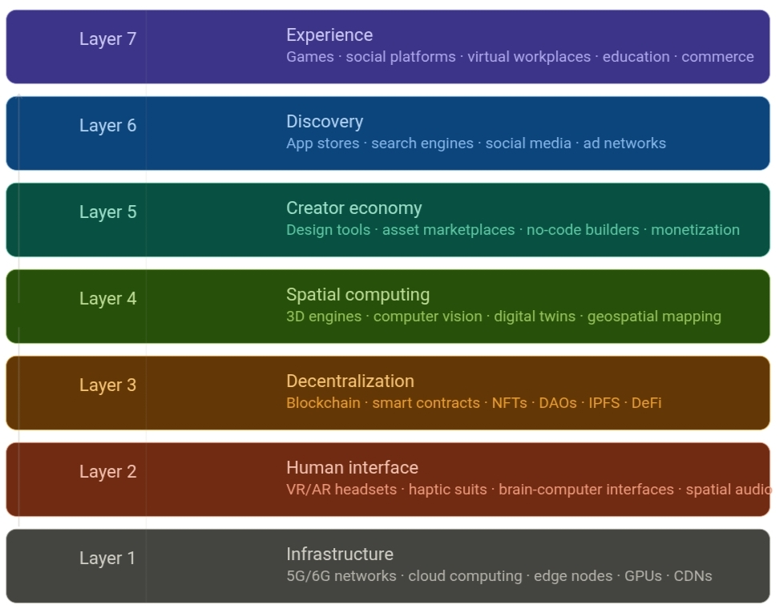

Figure 1.1: Metaverse Architecture Diagram — Seven-Layer Model

Layer 7 — Experience: The topmost layer represents the actual user-facing experiences of Metaverse games social platforms virtual workplaces educational environments entertainment venues and commercial spaces that users interact with directly.
Layer 6 — Discovery: This layer manages how users find access and navigate Metaverse experiences encompassing application stores social media platforms search and recommendation engines and advertising networks tailored for virtual environments.
Layer 5 — Creator Economy: The tools platforms and marketplaces that enable creators to design build and monetize virtual experiences constitute this layer including design software asset marketplaces such as OpenSea and Rarible no-code world-building tools and economic mechanisms for rewarding creators.
Layer 4 — Spatial Computing: This layer includes 3D game engines (Unreal Engine Unity) computer vision systems digital twin platforms geospatial mapping technologies and AI-driven world generation tools that create and maintain the virtual environments of the Metaverse.
Layer 3 — Decentralization: Blockchain networks and decentralized protocols form this layer providing trustless ownership verification digital asset provenance tracking smart contract execution and decentralized governance mechanisms. Key technologies include Ethereum Solana and Polygon blockchain networks as well as decentralized storage systems such as IPFS and Filecoin.
Layer 2 — Human Interface: This layer encompasses all hardware and software systems through which humans access and interact with the Metaverse. Key components include head-mounted displays (HMDs) for VR and AR smart glasses haptic gloves and suits brain-computer interfaces (BCIs) spatial audio systems and motion capture technologies.
Layer 1 — Infrastructure: This foundational layer comprises the physical and virtual infrastructure upon which the Metaverse is built including 5G/6G telecommunications networks cloud computing platforms (AWS Azure Google Cloud) edge computing nodes semiconductor hardware (GPUs specialized AI chips) and content delivery networks (CDNs).

CHAPTER 2
LITERATURE REVIEW
2.1 Literature Survey
A comprehensive review of existing academic literature industry reports and technical publications was conducted to understand the current state of Metaverse research. The following survey synthesizes key contributions from researchers and practitioners across multiple disciplines.
Mystakidis (2022) provided one of the most widely cited academic definitions of the Metaverse in the Encyclopedia of Education Technology describing it as the post-reality universe — a perpetual and persistent multiuser environment merging physical reality with digital virtuality [1]. This paper established a foundational taxonomy that subsequent researchers have built upon distinguishing between the immersive virtual worlds characteristic of the Metaverse and previous internet paradigms (Web 1.0 and Web 2.0).
Lee et al. (2021) conducted a systematic analysis of the Metaverse in their paper "All One Needs to Know about Metaverse: A Complete Survey on Technological Singularity Virtual Ecosystem and Research Agenda" [2]. This survey examined over 200 research papers and identified four primary categories of Metaverse applications: augmented reality lifelogging mirror world and virtual reality collectively termed the ALMA framework. The authors identified synchronization of the physical and virtual worlds as the primary technical challenge for full Metaverse realization.
Ning et al. (2021) explored the technical architecture of the Metaverse in "A Survey on the Metaverse: The State-of-the-Art Technologies Applications and Challenges" presenting a detailed technical analysis of enabling technologies including computer graphics extended reality digital twins AI and blockchain [3]. The paper proposed a three-layer reference architecture and identified key interoperability challenges as the most significant barriers to a unified Metaverse.
Dionisio Burns and Gilbert (2013) were among the first academic researchers to systematically define the properties of the Metaverse in their paper "3D Virtual Worlds and the Metaverse: Current Status and Future Possibilities" [4]. They identified four essential properties: realism (photorealistic rendering) ubiquity (universal accessibility) interoperability (cross-platform asset portability) and scalability (support for millions of simultaneous users). This framework remains influential in contemporary Metaverse research.
Park and Kim (2022) examined the Metaverse from an educational perspective in "A Metaverse: Taxonomy Components Applications and Open Challenges" investigating the use of immersive virtual environments for pedagogical innovation [5]. Their research highlighted that Metaverse-based learning environments demonstrated significant improvements in student engagement knowledge retention and collaborative learning outcomes compared to traditional educational formats.
Huynh-The et al. (2023) contributed a comprehensive survey on "Artificial Intelligence for the Metaverse: A Survey" examining the role of AI in enabling intelligent virtual agents personalized experience generation real-time content creation and security enforcement within Metaverse environments [6]. The study identified generative AI models particularly large language models (LLMs) and diffusion models as transformative enablers of scalable Metaverse content creation.
Wang et al. (2022) investigated the application of blockchain technology to Metaverse economies in "Survey on Metaverse: Fundamentals Security and Privacy" [7]. Their analysis covered NFT standards (ERC-721 ERC-1155) decentralized autonomous organizations (DAOs) and the emergent play-to-earn economic models pioneered by games such as Axie Infinity. The authors identified smart contract vulnerabilities and scalability limitations of current blockchain networks as significant security and performance concerns.
Falchuk Loeb and Nack (2018) explored social privacy concerns in virtual worlds in "The Social Metaverse: Battle for Privacy" providing early analysis of the data collection practices inherent in immersive virtual environments and their implications for user privacy [8]. Their prescient analysis anticipated many of the privacy controversies that have since emerged around Metaverse platforms particularly regarding biometric data gaze tracking and movement pattern collection.
Duan et al. (2021) presented the concept of the Metaverse Ecosystem in "Metaverse for Social Good: A University Campus Prototype" describing an implementation of Metaverse technologies within a university campus context [9]. This work demonstrated practical applications including virtual campus tours remote laboratory experiments and immersive academic conferences providing a concrete proof-of-concept for educational Metaverse applications.
Tlili et al. (2022) examined the use of the Metaverse in education in "Is Metaverse in Education a Blessing or a Curse: A Combined Content and Bibliometric Analysis" [10]. The meta-analysis reviewed 46 studies and found generally positive outcomes for immersive educational technologies but identified significant concerns around digital equity accessibility for students without high-end devices and the risk of social isolation.
Ball (2022) in his seminal book The Metaverse: And How It Will Revolutionize Everything provided a comprehensive industry perspective on the Metaverse drawing from extensive research and interviews with leading technologists and business leaders [11]. Ball argued that the Metaverse would represent the next major computing platform succeeding mobile internet in the same way that mobile succeeded desktop computing and projected that its full realization would require 10–15 years of continued technological development.
Radianti et al. (2020) surveyed VR applications in higher education in "A Systematic Review of Immersive Virtual Reality Applications for Higher Education" analysing 38 studies and finding that immersive VR applications demonstrated particular effectiveness for training complex procedures in medicine engineering and safety-critical industries [12]. The review identified content development cost and hardware accessibility as primary barriers to widespread adoption.
Cheng et al. (2022) investigated the intersection of digital twins and the Metaverse in "Will Metaverse Be NextG Internet? Vision Hype and Reality" [13]. Their analysis examined how digital twin technologies — precise virtual replicas of physical systems — could serve as the foundational infrastructure for Metaverse environments enabling real-time synchronization between physical and virtual worlds at unprecedented fidelity.
Zhou et al. (2021) examined the potential of the Metaverse for healthcare applications in a pioneering study identifying use cases including surgical simulation rehabilitation and telemedicine [14]. Their framework for Metaverse healthcare applications emphasized the importance of low-latency networking and haptic feedback for clinical applications where precision is paramount.
2.2 Summary of the Literature Survey
The literature reviewed reveals several convergent themes and insights that define the current understanding of the Metaverse across academic and industry communities.
First there is broad consensus that the Metaverse represents a convergence of multiple previously distinct technology domains — virtual reality blockchain AI spatial computing and high-speed networking — rather than a single new technology. This convergence creates both opportunities and challenges: the potential for synergistic capabilities across domains must be balanced against the complexity of integrating diverse systems developed by different organizations using different standards.
Second interoperability emerges consistently as the most significant unsolved technical challenge. The current Metaverse landscape is characterized by siloed platforms — each with its own virtual economy identity system and technical standards — that cannot communicate or exchange assets with one another. Achieving a truly unified Metaverse will require the development and adoption of open standards analogous to the HTML/CSS/JavaScript standards that enabled the interoperable World Wide Web [15].
Third the literature reveals significant potential across educational healthcare and enterprise domains with empirical evidence demonstrating measurable improvements in learning outcomes clinical training performance and collaborative productivity when immersive technologies are appropriately deployed. However researchers consistently note that these benefits are contingent on adequate hardware access raising concerns about exacerbating existing digital divide inequalities.
Fourth blockchain-based digital ownership and decentralized economic systems are identified as key innovations that distinguish the Metaverse from previous virtual world concepts enabling genuine user ownership of digital assets and the emergence of new economic models such as play-to-earn gaming and creator economies. However speculative excess environmental concerns related to proof-of-work consensus mechanisms and regulatory uncertainty are identified as risks to sustainable growth of these models.

CHAPTER 3
TECHNICAL SIGNIFICANCE
3.1 Technological Developments
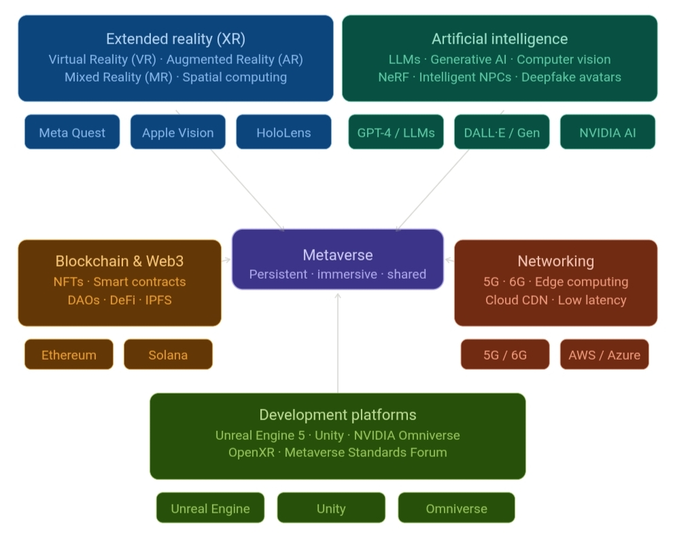
The Metaverse is being shaped by a constellation of technological advances occurring simultaneously across multiple domains. Understanding these developments is essential for appreciating both the current state of Metaverse implementation and the trajectory of future progress.
Figure 3.1: Metaverse Technology Stack Diagram
3.1.1 Extended Reality (XR) Hardware
The hardware enabling immersive Metaverse experiences has undergone dramatic improvement in recent years. The release of Apple Vision Pro in 2024 demonstrated a new generation of spatial computing devices capable of seamlessly blending virtual and physical environments at unprecedented visual fidelity [16]. Meta's Quest series of standalone VR headsets has lowered the price barrier for consumer VR adoption while enterprise-focused devices such as Microsoft HoloLens have demonstrated compelling augmented reality applications. Key technological improvements driving progress include higher-resolution displays reducing the "screen door effect" wider field-of-view optics inside-out positional tracking eliminating external sensor requirements eye-tracking for foveated rendering and significant reductions in headset weight and thermal management challenges.
3.1.2 Artificial Intelligence and Generative AI
The emergence of large language models (LLMs) and generative AI has profoundly accelerated Metaverse development possibilities [17]. AI-generated 3D environments photorealistic avatars intelligent NPC behaviours and real-time natural language interfaces dramatically reduce the cost and time required to create rich Metaverse content. Models such as NVIDIA's GET3D and Point-E enable automatic generation of three-dimensional objects from text descriptions while neural radiance fields (NeRF) and Gaussian splatting technologies enable the conversion of photographic or video content into immersive 3D environments.
3.1.3 Blockchain and Web3 Infrastructure
The transition from proof-of-work to proof-of-stake consensus mechanisms exemplified by Ethereum's "Merge" in September 2022 reduced the energy consumption of the Ethereum network by approximately 99.95% addressing a major criticism of blockchain-based Metaverse economies [18]. Layer 2 scaling solutions such as Polygon Optimism and Arbitrum have dramatically increased transaction throughput and reduced transaction costs making micropayment-based economic models within the Metaverse financially viable.
3.1.4 Networking Infrastructure
The global rollout of 5G networks has begun delivering the low-latency high-bandwidth connectivity required for responsive immersive experiences. 5G's theoretical peak data rate of 20 Gbps and latency below 1 millisecond enable real-time streaming of high-fidelity virtual environments to edge devices reducing the computational burden on user-side hardware [19]. Research into 6G technologies targets even more ambitious specifications including terahertz spectrum utilization and sub-microsecond latency which would enable entirely new categories of Metaverse applications including tactile internet experiences.
3.1.5 Digital Twin Technology
Digital twin technology — the creation of precise virtual replicas of physical objects systems or environments — is increasingly recognized as a critical infrastructure component for the Metaverse [20]. Major implementations include NVIDIA Omniverse which enables the creation of detailed digital twins of industrial facilities urban environments and supply chains. The integration of IoT sensor data enables real-time synchronization between physical and digital twins creating what some researchers term the "Mirror World" aspect of the Metaverse.
3.2 Tools and Technologies
The Metaverse ecosystem is supported by a rich set of development tools platforms and enabling technologies. The following outlines the key components currently driving Metaverse development and deployment.
3.2.1 Game Engines and Development Platforms
Unreal Engine 5 developed by Epic Games is widely regarded as the most technically advanced real-time 3D development platform available featuring Nanite virtualized geometry Lumen global illumination and MetaHuman Creator for photorealistic avatar generation [21]. Unity Technologies' Unity Engine is the most widely adopted game engine by market share favored for its accessibility to independent developers and robust cross-platform deployment capabilities. NVIDIA Omniverse provides a specialized platform for collaborative 3D content creation and digital twin development with built-in physics simulation and photorealistic rendering.
3.2.2 Blockchain Platforms and NFT Standards
Ethereum remains the dominant blockchain platform for Metaverse applications supporting the ERC-721 and ERC-1155 token standards that underpin NFT-based digital ownership. Alternative blockchain platforms including Solana (optimized for high-throughput low-fee transactions) Flow (designed specifically for NFT gaming applications) and Polygon (an Ethereum Layer-2 scaling solution) provide platforms for specific Metaverse use cases [22].

3.2.3 Major Metaverse Platforms
Current Metaverse platforms span a spectrum from centralized consumer platforms to decentralized virtual worlds. Meta Horizon Worlds provides a social VR environment integrated with Meta's Quest hardware ecosystem. Decentraland and The Sandbox offer blockchain-based virtual worlds where users own land parcels and can develop monetizable experiences. Roblox with over 70 million daily active users represents the largest existing proto-Metaverse platform by user engagement. Microsoft Mesh targets enterprise collaboration use cases through integration with Teams and Azure cloud infrastructure.
Table 3.1: Comparison of Major Metaverse Platforms
Platform | Type | Blockchain | Key Feature
Meta Horizon Worlds | Centralized | None | Social VR Quest integration
Decentraland | Decentralized | Ethereum | User-owned land (MANA)
The Sandbox | Decentralized | Ethereum | UGC gaming (SAND token)
Roblox | Centralized | None | Largest user base UGC
Microsoft Mesh | Enterprise | None | Azure-powered collaboration
NVIDIA Omniverse | Enterprise/Dev | None | Digital twins simulation

3.2.4 Interoperability Standards
The development of open interoperability standards is recognized as critical for the realization of an open Metaverse. The Open Metaverse Interoperability Group (OMI) and the Metaverse Standards Forum — whose members include Apple Meta Microsoft NVIDIA and Sony — are working to develop common standards for avatar portability asset formats and communication protocols [23]. The OpenXR standard maintained by the Khronos Group provides a hardware-agnostic API for XR application development enabling software to run across different headset platforms without modification.

Table 3.2: Summary of Key Tools and Technologies
Category | Tool / Technology | Purpose
3D Engine | Unreal Engine 5 | Real-time rendering world-building
3D Engine | Unity | Cross-platform XR development
Digital Twin | NVIDIA Omniverse | Collaborative simulation
Blockchain | Ethereum | NFTs smart contracts
Blockchain | Solana | High-throughput transactions
Networking | 5G / 6G | Low-latency connectivity
AI | LLMs / Diffusion Models | Content generation
Standard | OpenXR | Hardware interoperability

3.3 Sustainability and Societal Concern
While the technological potential of the Metaverse is considerable its development raises profound sustainability and societal concerns that must be proactively addressed by technologists policymakers and society at large.
3.3.1 Energy Consumption and Environmental Impact
The Metaverse's computational requirements — encompassing real-time 3D rendering AI processing blockchain transactions and data center operations — carry substantial energy implications. Data centers already consume approximately 1–2% of global electricity demand and the scaling required to support billions of concurrent Metaverse users represents a significant additional load [24]. However mitigation pathways exist through renewable energy procurement energy-efficient hardware design algorithmic optimization and the continued transition to proof-of-stake consensus mechanisms in blockchain networks.
3.3.2 Digital Inclusion and Accessibility
The Metaverse risks exacerbating existing digital inequalities if its development prioritizes premium experiences accessible only to those with high-end hardware and high-bandwidth internet connectivity. High-quality VR headsets remain expensive for many global consumers and the infrastructure required for low-latency immersive experiences is not uniformly distributed geographically or socioeconomically. Ensuring equitable access to Metaverse benefits will require deliberate policy interventions subsidized hardware programs and the development of lightweight low-bandwidth access modalities.
3.3.3 Privacy and Data Security
The Metaverse collects unprecedented quantities of sensitive personal data including biometric identifiers (facial geometry iris patterns voice prints) physiological signals (heart rate emotional arousal indicators from eye tracking) behavioral patterns (movement interaction preferences social relationships) and economic transaction histories [25]. The aggregation of such data creates significant risks of surveillance manipulation and exploitation. Robust privacy-by-design principles transparent data governance frameworks and strong regulatory oversight — potentially building on GDPR and similar frameworks — are essential prerequisites for trustworthy Metaverse development.
3.3.4 Mental Health and Psychological Impact
Extended immersion in virtual environments raises concerns about psychological wellbeing including the risk of addiction or compulsive use identity and reality confusion social isolation as virtual relationships substitute for physical ones and exposure to harmful content including harassment hate speech and exploitation. The anonymity afforded by virtual avatars can facilitate antisocial behaviours and the absence of mature content moderation systems on many current Metaverse platforms has already resulted in documented incidents of online harassment and abuse. Dedicated research into the psychological impacts of Metaverse immersion and robust platform safety policies are urgently required.
3.3.5 Regulatory and Legal Frameworks
The transnational nature of the Metaverse — in which users from different legal jurisdictions interact in virtual spaces hosted by corporate entities operating under yet other jurisdictions — creates complex legal and regulatory questions. Issues of jurisdiction liability intellectual property enforcement taxation of virtual economic activity and the legal status of virtual assets and contracts remain largely unresolved. International regulatory cooperation will be essential to develop coherent frameworks that protect users while enabling innovation.
3.4 Conclusion
The Metaverse represents one of the most consequential technological developments of the 21st century with the potential to reshape how humans work learn socialize conduct commerce and experience culture. The convergence of virtual and augmented reality blockchain-based digital ownership artificial intelligence and advanced networking infrastructure is creating the foundational conditions for persistent immersive digital worlds that may eventually be as economically and socially significant as the physical world.
This seminar has examined the Metaverse from multiple perspectives: its conceptual foundations and architectural principles its diverse applications across sectors including entertainment education healthcare and enterprise the technological developments driving its evolution and the critical sustainability and societal concerns that must be addressed for its responsible development.
The literature review reveals a maturing academic understanding of the Metaverse with researchers across disciplines contributing rigorous frameworks for analyzing its technical requirements social implications and ethical dimensions. The consensus from this body of research is that the Metaverse holds genuine transformative potential but that realizing this potential equitably and responsibly will require sustained collaborative effort from technologists policymakers educators civil society and communities.
Key challenges remain in the areas of interoperability and open standards energy efficiency and environmental sustainability digital inclusion and equitable access privacy and data governance mental health safeguarding and regulatory clarity. Progress on these challenges will determine whether the Metaverse ultimately becomes a technology that enriches human experience broadly or one that exacerbates existing inequalities and introduces new risks.
As the technologies underpinning the Metaverse continue to advance — with XR hardware becoming more capable and affordable AI enabling richer and more accessible content creation and blockchain infrastructure becoming more efficient and scalable — the realization of a genuinely transformative Metaverse moves progressively closer. The imperative for researchers technologists and policymakers is to ensure that this transformation unfolds in a manner that is inclusive sustainable safe and genuinely beneficial to humanity.

BIBLIOGRAPHY
[1] N. Stephenson Snow Crash. New York: Bantam Books 1992.
[2] S. Mystakidis "Metaverse" Encyclopedia vol. 2 no. 1 pp. 486–497 Feb. 2022 doi: 10.3390/encyclopedia2010031.
[3] L.-H. Lee T. Braud P. Zhou L. Wang D. Xu Z. Lin A. Kumar C. Bermejo and P. Hui "All One Needs to Know about Metaverse: A Complete Survey on Technological Singularity Virtual Ecosystem and Research Agenda" J. Latex Class Files vol. 14 no. 8 pp. 1–66 Sep. 2021.
[4] H. Ning H. Wang Y. Lin W. Wang S. Dhelim F. Farha J. Ding and M. Daneshmand "A Survey on the Metaverse: The State-of-the-Art Technologies Applications and Challenges" IEEE Internet Things J. vol. 10 no. 16 pp. 14671–14688 Aug. 2023 doi: 10.1109/JIOT.2023.3278329.
[5] J. D. N. Dionisio W. G. Burns III and R. Gilbert "3D Virtual Worlds and the Metaverse: Current Status and Future Possibilities" ACM Comput. Surv. vol. 45 no. 3 pp. 1–38 Jun. 2013 doi: 10.1145/2480741.2480751.
[6] S. M. Park and Y. G. Kim "A Metaverse: Taxonomy Components Applications and Open Challenges" IEEE Access vol. 10 pp. 4209–4251 2022 doi: 10.1109/ACCESS.2021.3140175.
[7] J. Radoff "The Metaverse Value Chain" Building the Metaverse (blog) Apr. 7 2021. [Online]. Available: https://medium.com/building-the-metaverse/the-metaverse-value-chain-afcf9e09e3a7
[8] T. Huynh-The Q.-V. Pham X.-Q. Pham T. T. Nguyen Z. Han and D.-S. Kim "Artificial Intelligence for the Metaverse: A Survey" Eng. Appl. Artif. Intell. vol. 117 p. 105581 Jan. 2023 doi: 10.1016/j.engappai.2022.105581.
[9] Y. Wang Z. Su N. Zhang R. Xing D. Liu T. H. Luan and X. Shen "A Survey on Metaverse: Fundamentals Security and Privacy" IEEE Commun. Surv. Tutor. vol. 25 no. 1 pp. 319–352 2023 doi: 10.1109/COMST.2022.3202047.
[10] B. Falchuk S. Loeb and R. Nack "The Social Metaverse: Battle for Privacy" IEEE Technol. Soc. Mag. vol. 37 no. 2 pp. 52–61 Jun. 2018.
[11] H. Duan J. Li S. Fan Z. Lin X. Wu and W. Cai "Metaverse for Social Good: A University Campus Prototype" in Proc. 29th ACM Int. Conf. Multimedia New York NY USA: ACM 2021 pp. 153–161.
[12] A. Tlili B. Shehata M. A. Adarkwah A. Bozkurt D. T. Hickey R. Huang and B. Agyemang "Is Metaverse in Education a Blessing or a Curse: A Combined Content and Bibliometric Analysis" Smart Learn. Environ. vol. 9 no. 1 p. 24 2022.
[13] M. Ball The Metaverse: And How It Will Revolutionize Everything. New York: Liveright Publishing 2022.
[14] J. Radianti T. A. Majchrzak J. Fromm and I. Wohlgenannt "A Systematic Review of Immersive Virtual Reality Applications for Higher Education: Design Elements Lessons Learned and Research Agenda" Comput. Educ. vol. 147 p. 103778 Apr. 2020 doi: 10.1016/j.compedu.2019.103778.
[15] R. Cheng N. Wu S. Chen and B. Han "Will Metaverse Be NextG Internet? Vision Hype and Reality" in Proc. IEEE 6th Int. Conf. Fog Mobile Edge Comput. (FMEC) 2022 pp. 1–6.
[16] Apple Inc. "Apple Vision Pro" press release Jun. 5 2023. [Online]. Available: https://www.apple.com/newsroom/2023/06/introducing-apple-vision-pro/
[17] M. Grieves and J. Vickers "Digital Twin: Mitigating Unpredictable Undesirable Emergent Behavior in Complex Systems" in Transdisciplinary Perspectives on Complex Systems F.-J. Kahlen S. Flumerfelt and A. Alves Eds. Cham: Springer 2017 pp. 85–113.
[18] Ethereum Foundation "The Merge" Ethereum.org Sep. 2022. [Online]. Available: https://ethereum.org/en/upgrades/merge/
[19] J. G. Andrews S. Buzzi W. Choi S. V. Hanly A. Lozano A. C. K. Soong and J. C. Zhang "What Will 5G Be?" IEEE J. Sel. Areas Commun. vol. 32 no. 6 pp. 1065–1082 Jun. 2014.
[20] A. Ante "Non-Fungible Token (NFT) Markets on the Ethereum Blockchain: Temporal Development Cointegration and Transaction Count Analysis" Small Bus. Econ. vol. 61 pp. 1775–1799 2023.
[21] Epic Games "Unreal Engine 5 Features" Unreal Engine Documentation 2022. [Online]. Available: https://www.unrealengine.com/en-US/unreal-engine-5
[22] Fortune Business Insights "Metaverse Market Size Share & COVID-19 Impact Analysis" Fortune Business Insights Pune India Market Research Report FBI-106805 2022.
[23] Metaverse Standards Forum "Welcome to the Metaverse Standards Forum" metaverse-standards.org 2022. [Online]. Available: https://metaverse-standards.org/
[24] E. Masanet A. Shehabi N. Lei S. Smith and J. Koomey "Recalibrating Global Data Center Energy-Use Estimates" Science vol. 367 no. 6481 pp. 984–986 Feb. 2020.
[25] S. Mystakidis G. Christopoulos and S. Pellas "A Systematic Mapping Review of Augmented Reality Applications to Support STEM Learning in Higher Education" Educ. Inf. Technol. vol. 27 no. 2 pp. 1883–1927 2022.

